**Understanding role of point defects on electronic properties in 2D materials**

Dual Degree Thesis Report

*Submitted in partial fulfilment of the requirements for the degree of Bachelor of Technology & Master of Technology*

By

**Shashank Raut Desai**

(Roll No. **17D110006**)

Supervisor:

**Prof. Sumit Saxena**



Department of Metallurgical Engineering and Materials Science

INDIAN INSTITUTE OF TECHNOLOGY BOMBAY

(October 2021)

**Declaration**

I declare that this written submission represents my ideas in my own words and where others ideas or words have been included; I have adequately cited and referenced the original source. I also declare that I have adhered to all principles of academic honesty and integrity and have not misrepresented or fabricated or falsified any idea/data/fact/ source in my submission. I understand that any violation of the above will be cause for disciplinary action by the institute and can evoke penal action from the sources, which have thus not been properly cited, or from whom the proper submission has not been taken when needed.

**___________________**

Shashank Raut Desai  
17d110006

**Approval Sheet**

Dissertation titled ‘Understanding role of point defects on electronic properties in 2D materials’ by Mr. Shashank Raut Desai is approved for the Dual Degree (Bachelor of Technology & Master of Technology) in Metallurgical Engineering and Materials Science (MEMS) at IIT Bombay.

**Examiner(s):**

________________

**Supervisor:**

________________

**Chairman:**

________________

**Date: _____________**

**Place: _**____________

**Acknowledgement**

I would like to express my heartfelt thanks and sincere respect for my guide, Prof. Sumit Saxena, for sharing his immense knowledge with me and empowering me with the art and science of research. His constant motivation and capable counsel inspired me, instilling me with a sense of self-assurance. I also want to thank the Metallurgical Engineering and Material Science Department, Indian Institute of Technology, Bombay for giving me the opportunity and resources to work on this riveting topic.

I am deeply grateful to Dr. Basant Roondhe for easing me into the world of molecular simulations and helping me in getting comfortable with simulation software. His consistent encouragement has shaped my interest in this field.

Finally, I would like to thank my family for their endless support and countless sacrifices, for which I am eternally obliged.

**Abstract**

Ever since Novoselov and Geim successfully isolated the single-layer graphene in 2004 and published their paper, the field of two-dimensional materials has seen a renaissance of interest by research groups all over the world after a few decades, with their paper in the Science journal becoming one of the hundred most cited papers of all time. The outstanding properties exhibited by graphene and the ensuing masses of 2D materials synthesized thereafter, have proven to be useful for an endless set of applications. In this report, we examine what constitutes a 2D material, their general electrical, mechanical and optical properties and some popular classes of 2D materials.

Further, we study molybdenum disulphide, one of the most researched 2D materials, and its properties along with some of its applications in the fields of electronics, medicine and energy. Next, the types of defects that exist in 2D materials are studied, with special emphasis on the defects found in molybdenum disulphide. We proceed to conduct computational studies on vacancy defects found in MoS2 using Quantum Espresso to perform ab initio electronic structure calculations and present our results, along with laying the path for future work.

**List of Figures**

Figure 1: Examples of different types of structures, classified by dimensions [3] (Creative Commons License) 7

Figure 2: Representative Diagram of Mechanical Exfoliation [15] (Creative Commons License) 12

Figure 3: Representative Diagram of Chemical Exfoliation [15] (Creative Commons License) 13

Figure 4: Band structure of graphene [19] (Creative Commons License) 14

Figure 5: Graphene monolayer [21] (Creative Commons License) 15

Figure 6: Two-dimensional structure of WTe2 [25] (Creative Commons License) 16

Figure 7: Buckled hexagonal structure of stanene and silicene, respectively [27] (Creative Commons License) 17

Figure 8: Types of monolayer MoS2: 1T (left), 2H (right) [31] (Creative Commons License) 18

Figure 9: Effect of various agents on cancer cells in mice [37] (Creative Commons License) 21

Figure 10: 1. Block diagram of conventional imaging system, 2. Neuromorphatic imaging device [40] (Creative Commons License) 21

Figure 11: Reconstructed vacancy in graphene with atomic configuration - 9 and 5 membered ring [46] (Creative Commons License) 24

Figure 12: SW defect in graphene [46] (Creative Commons License) 24

Figure 13: (1,1) Line defect in graphene [22] (Creative Commons License) 25

Figure 14: Grain boundary defect [22] (Creative Commons License) 26

Figure 15: Sulphur monovacancy VS point defect [48] (Creative Commons License) 27

Figure 16: Vacancy complex VMoS3 [48] 27

Figure 17: 5|7 dislocation in MoS2 [48] (Creative Commons License) 28

Figure 18: 4|6 dislocation in MoS2 [48] (Creative Commons License) 28

Figure 19: 4|4P 60o grain boundary structure [48] (Creative Commons License) 29

Figure 20: Flowchart of unit cell optimization 32

Figure 21: Optimization of Kinetic Energy Cutoff 33

Figure 22: Optimization of Monkhorst-Pack Grid 34

Figure 23: 1x1x1 MoS2 unit cell, visualized in Xcrysden 34

Figure 24: K-Path Selection 35

Figure 25: Band structure of pristine monolayer MoS2 36

Figure 26: Density of states for pristine monolayer MoS2 36

Figure 27: 3x3x1 MoS2 supercell, visualized in Xcrysden, with S atom to be removed marked in green 37

Figure 28: 3x3x1 MoS2 supercell, visualized in Xcrysden, with S atom removed 37

Figure 29: Band structure of MoS2 with Vs defect 38

Figure 30: Density of states plot of MoS2 with Vs defect 39

**Table of Contents**

1. Introduction 8

1.1 Zero Dimensional Nanostructured Materials 9

1.2 One Dimensional Nanostructured Materials 9

1.3 Two Dimensional Nanostructured Materials 9

1.4 Three Dimensional Nanostructured Materials 10

2. Two Dimensional Materials 11

2.1 Properties of 2D 11

2.1.1 Electrical Properties 11

2.1.2 Optical properties of 2D materials 12

2.1.3 Mechanical properties of 2D materials 12

2.2 Methods of Synthesis 13

2.2.1 Top Down Approach 13

2.2.2 Bottom-up approach 14

2.3 Some important types of two-dimensional materials 15

2.3.1 Graphene 15

2.3.2 Two Dimensional Transitional Metal Dichalcogenides 16

2.3.3 Xenes 17

3. Molybdenum disulphide 19

3.1 Introduction 19

3.2 Properties 19

3.3 Applications of MoS2 21

3.3.1 Medical Applications 21

3.3.2 Electronic Applications 22

3.3.3 Energy Applications 23

4. Point Defects 24

4.1 Introduction to defects in 2D materials 24

4.2 Types of defects in 2D materials 24

4.2.1 Zero Dimensional 24

4.2.2 One Dimensional 26

4.3 Defects observed in MoS2 27

4.3.1 Point Defects 27

4.3.1 Dislocations and GBs 28

4.4 Why study point defects? 30

5. Density Functional Theorem 31

5.1 Need for Computational Studies 31

5.2 Origin of Computational Studies 31

6. Results 33

6.1 Background 33

6.2 Computation Process 33

7. Summary & Future work 40

7.1 Summary 40

7.2 Future Work 40

8. References 41

# 1. Introduction

The 21st century has seen a rapid increase in the pace of development in technology. For this development, a dominant aspect to study is the material system behind the technology. Here, material system refers to the characteristics of the material, behaviour of the material and the like. Each material has its own distinct set of properties which can be used for different types of applications. [1]

The size of material is a key factor in determining the characteristics of a material. This is because the nature of the material itself varies with the size at which we observe the properties of the material. At the nanoscale size, the behaviour as well as the chemical, mechanical and electrical characteristics of the material vary tremendously. Materials with at least one dimension in the range of 1nm to 100nm are classified as nanomaterials. Pokropivny and Skorokhod [2] proposed a classification scheme for nanomaterials under which they can be divided into four types of materials: zero-dimensional, one-dimensional, two-dimensional and three-dimensional. Depending on their properties, materials may

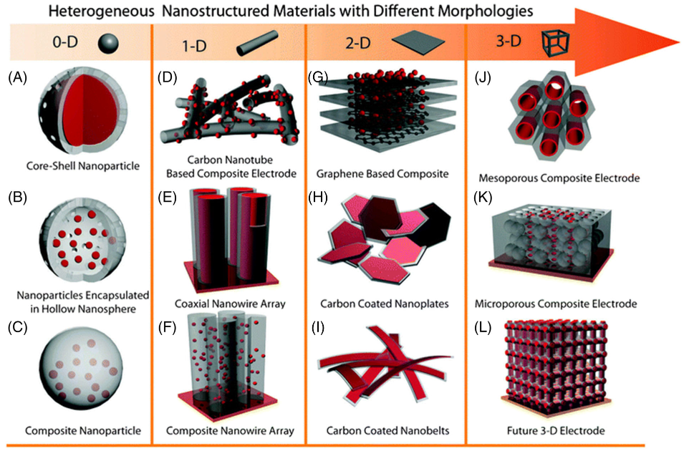

Figure : Examples of different types of structures, classified by dimensions [3] (Creative Commons License)

vary by shape, by their atomic structure and even by states to be in the bulk form, solution form or liquid form.

## 1.1 Zero Dimensional Nanostructured Materials

If all of the three dimension of a material are nanosized, that is, in the range of 1nm to 100nm, then the material is a 0D NSM (nanostructured materials). [1] Several physical and chemical techniques of fabrication of 0D nanomaterials have evolved. Multiple research groups have managed to synthesize quantum dots (homogeneous particle arrays), heterogeneous particles arrays, core shell quantum dots, onions, hollow spheres and nanolenses. [3]

## 1.2 One Dimensional Nanostructured Materials

When two dimensions of a material are nanosized, that is, in the range of 1nm to 100nm, and one dimension is in the range of 1mm to 10cm, then the material is a 1D NSM. [1] 1D NSMs have generated a lot of interest and have a variety of potential applications. Conventionally, 1D NSMs are ideal to study several novel phenomena at nanoscale as well as relation of material behaviour with size and dimensionality. Some examples of 1D NSMs are nanorods (solid nanofiber), nanowires (electrically conducting/semi-conducting nanofiber), nanobelts, nanotubes (hollow nanofiber), hierarchical nanostructures and nanoribbons. In the future, 1D NSMs are anticipated to be vital as the interconnects as well as the main component in producing electronic and optoelectronic nanodevices. [3]

## 1.3 Two Dimensional Nanostructured Materials

When only one of the three dimensions of a material is in the range of 1nm to 100nm and the other two dimensions are larger than nanoscale size, then the material is considered a 2D nanostructured material. [1] Some examples include nanosheet, nanowall, nanodisk, nanoprism and so on. With certain geometry, they show characteristic characteristics which vary with shape and hence, they can be used as building block of important constituents of nanodevices. 2D materials can also be used for fabricating devices like sensors, transistors, photodetectors, battery electrodes, photocatalyst, nanoreactors and templates for 2D structures of other NSMs. [3]

## 1.4 Three Dimensional Nanostructured Materials

When all the three dimensions of a material are greater than nanosize (range of 1nm to 100nm) that is, micro or larger in size, then the material is considered a 3D nanostructured material. [1] Some examples of 3D NSMs include nanopillers, nanoballs, nanoflowers nanocoils and nanocones. Due to their larger surface and sufficient sites of absorption in a limited space, they have garnered significant interest. Substances with porousness in all the 3 dimensions may give rise to better molecular transport. [3]

In our paper, we’ll focus on studying two-dimensional materials and the unique properties  
they exhibit rising from point defects in their structure.

# 2. Two Dimensional Materials

Ever since Novoselov and Geim [4] were able to successfully isolate the single layer graphene, there has been explosive interest in the field of two-dimensional materials. Two-dimensional materials offer unique possibilities to study previously uncharted areas of materials science. The ultra low thickness that 2D materials provide, make them suitable for use in electronics like FETs (field effect transistors) in which a small size of equipment enhances performance of the device as well as cuts down on the short-channel effects between the contacts. [5] MLs (monolayers) vary significantly in their physical properties from the parent three-dimensional materials as MLs furnish an extra DOF (degree of freedom) for various applications and give rise to phenomena like composite excitations (trions) and valley Hall effect. Additionally, van der Waals heterostructures rose up as an area to fabricate unique phenomena by stacking layers of two dimensional materials as required. [6]

## 2.1 Properties of 2D

### 2.1.1 Electrical Properties

In two-dimensional semi-conductors, electrical properties are conventionally confirmed by the exhibition of the field effect in FETs. A lot of research has been done to improve FET devices viz a viz their performance, with special interest in optimising the device junction. According to Lim and his team, a unique FET comprising a 2D MoS2-black phosphorus hetero-junction would show exceptionally low sub-threshold swing (54mV/dec) high ON/OFF ratio greater than 10­­­7 and low off current at 1 A. [7] The small value of off current is due to the presence of a depletion region in black phosphorus. The FET properties of a device can be improved by inserting a TiO2 interfacial layer between 2D transition metal dichalcogenide (TMDC) like WSe2 and metal. [8] Electrical properties can be stabilized under gate bias stress condition because the interfacial layer will perform Fermi level depinning, hence reducing density of interface states. [9] The preparation of p type MoS2 is generally required for the complementary integration of n and p type 2D materials. Adding a dopant precursor of P2O5 during production of MoS2 via CVD can yield p type semiconducting properties, according to Lee et al. [10] When compared to undoped n-type MoS2, the p-type doped monolayer MoS2 demonstrated p-type conduction with field effect mobility of 0.023 cm2/Vs an ON-OFF ratio of 103. The p-doped FET's performance should be improved even further. Recently, in the development of a neuromorphic hardware system, artificial synapse devices have become regarded as one of the most important components. It's very important to seek a physical parameter that properly regulates synaptic plasticity. [9] In a paper by Kim et al, a 2D FET with Nb2O5/ WSe2/NbSe2 heterostructure which utilized thickness of Nb2O5 layer to regulate the post synaptic current, hence regulating synaptic plasticity. [11]

### 2.1.2 Optical properties of 2D materials

2D materials often exhibit novel optical properties, which have been researched by several groups. [9] Utilizing ultrathin AFM tips, reversibly controllable photoluminescence was achieved during ferroelectric polarisation reversal using thin semiconductor MoS2/ferroelectric lead zirconium titanate heterostructure sheets. [12] The spontaneous polarisation of ferroelectric thin films impacts the opto electronic properties of MoS2.

Raman spectra of black phosphorus deposited on a Ge-coated dimethicone substrate was investigated, and distinct peak shifting rates for the Ag1, B2g, and Ag2 modes were observed for various BP layer thicknesses. [13] The observation of the strain–Raman spectrum relationship revealed a maximum uniaxial strain of 0.89 percent. This shifting phenomena was accurately recorded. According to research on PL and Raman spectrum undertaken by Zhang et al, bilayer MoS2 was benchmarked with ML MoS2. Doping along with substrate-film strain cause interlayer difference. PL and Raman spectroscopy can identify surface variations with thickness of less than mono-atom layer, thus generating insightful data regarding the impact of 2D vdW (van der Waals) homo and hetero structures on its optical properties. [9]

### 2.1.3 Mechanical properties of 2D materials

Several 2D materials have gathered a lot of interest for their unique mechanical properties. Two-dimensional materials have high elastic modulus, extremely low weight, excellent carrier mobility, high strength and high anisotropy in out-of-plane and in-plane mechanical properties. Covalent bonding attaches neighbouring atoms in the same plane, whereas weak vdW forces hold together the interlayers. [14] These weak vdW forces enable layers to slide over each other when stress coplanar with surface area is applied, hence causing lubrication. Adding WS2 nanoflowers in paraffin oil can improve abrasion and wear protection. This is because of nanoflowers’ morphology, which leads to formation of a uniform tribofilm during the sliding motion. [9]

## 2.2 Methods of Synthesis

Since some materials have 3D molecular linkages, thinning the substance necessitates breaking these links, leaving behind hanging bonds. Such a 2D material would have dangling bonds which are highly chemically and thermodynamically unstable, leading it to rearrange its shape in order to minimise its surface energy. A graphite allotrope contains solid chemical linkage along the planes in bulk material.

These layers are piled together and kept together by a weak vdW force, but can be separated with no loose bonds. The methods of synthesizing two dimensional materials can be classified in two categories: top down and bottom up. [1]

### 2.2.1 Top Down Approach

#### 2.2.1.1 Mechanical Exfoliation

Novoselov and Geim used mechanical exfoliation to synthesize graphene in 2004. In this method, a piece of adhesive tape is placed on the stacked material's surface and peeled away, leaving flakes behind. The flakes can be deposited on the substrate by pressing Scotch tape against it. This process produces a limited yield of MLs, with no modulation of size or shape. The ML produced has few defects and sufficient size in the range of 1-100μm. This is not suitable for large scale manufacturing. [1]

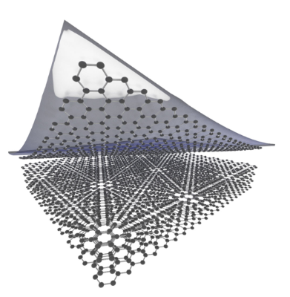

Figure : Representative Diagram of Mechanical Exfoliation [15] (Creative Commons License)

#### 2.2.1.2 Liquid Exfoliation

An organic solvent is employed as a medium to apply mechanical force to the substance (generally a powder suspended in liquid). By transferring tensile stress to layers of material, sonication causes them to split. Reactive ions are added (which form hydrogen bubbles between planes) to push layers apart or solution is rapidly mixed to increase shear force to enhance ML yield. This method produces low yield of MLs with smaller flakes lesser than 100nm in size. These flakes have high concentration of defects along with residual solvent. [1]

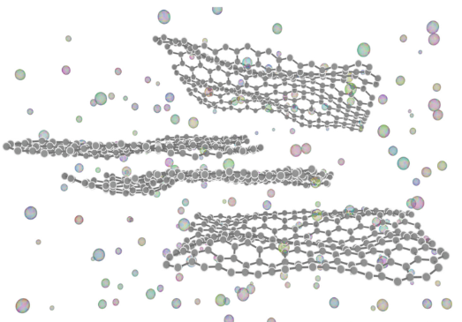

Figure : Representative Diagram of Chemical Exfoliation [15] (Creative Commons License)

### 2.2.2 Bottom-up approach

#### 2.2.2.1 Chemical synthesis in solution

Some wet chemical methods of chemical synthesis of 2D materials include: reactions in solutions under high temperature, amalgamation of nanoparticles into nanosheets, interface-controlled growth and so on. These can be used to synthesize most types of 2D materials. This method also produces low yield of MLs with smaller flakes lesser than 100nm in size. This method can be scaled up at a cheap cost. [16]

#### 2.2.2.1 Chemical Vapour Deposition

The precursor gases are pass through a preheated furnace in which either the gases diffuse together or get adsorbed onto a substrate forming a thin layer of the required substance. Factors like pressure temperature and time to complete the reaction must be regulated since they modulate the thickness and quality of film. This can method can be used at large scale to synthesize high quality films. [17]

## 2.3 Some important types of two-dimensional materials

### 2.3.1 Graphene

Graphene was the first two-dimensional element to be discovered. While graphene has been studied theoretically for more than fifty years, it was considered to be too energetically unstable to be isolated. It was first synthesized by Geim and Novoselov in 2004. Since then, owing to its outstanding mechanical, optical and electrical characteristics along with presence of massless Dirac fermion quasiparticles in graphene, it has received an outburst of research attention. [18] Eventually, it garnered the Nobel Prize for Physics in 2010 for Geim and Novoselov. Graphene has a hexagonal

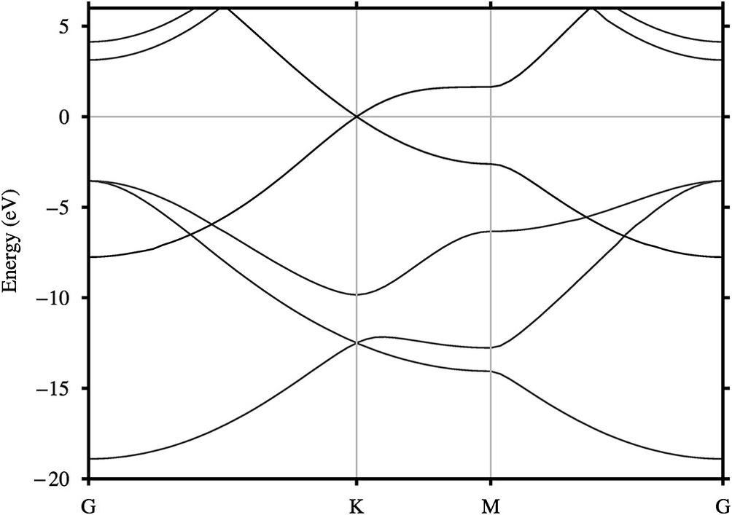

Figure : Band structure of graphene [19] (Creative Commons License)

structure of sp2 hybridised carbon atoms that is one atom thick and held together by covalent bonds. On observing its band structure, we can see that the conduction band and valence band overlap. Because of its unusual band structure, electrons flow at extremely high speeds (~1/300 the speed of light), giving it unique features including thermal conductivity. [1]

Graphene possesses the greatest tensile strength as compared to any other material in the world. Graphene is optically transparent and 98% of visible light incident on its surface passes through it. The thickness of its ML is roughly 0.3nm. [1]

The Fermi level can be found at the Dirac point where no electronic DOS is expected to exist for charge carrier transport in the case of no electrostatic doping, according to the transfer characteristics of a graphene field effect transistor. The linear and symmetric E-k dispersion at Dirac point causes the symmetry observed around the charge neutrality point, resulting in ambipolar transport characteristics. [20]

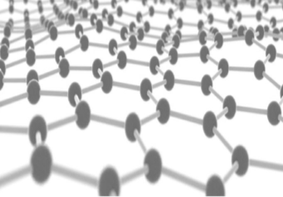

Figure : Graphene monolayer [21] (Creative Commons License)

### 2.3.2 Two Dimensional Transitional Metal Dichalcogenides

Transitional metal dichalcogenides have the chemical formula of MX2. Here, M refers to a transition metal like tungsten, tantalum, bismuth, nickel and so on. X refers to chalcogen like sulphur, tellurium or selenium. [22]

In TMDCs, the bonding between atoms in the same layer is covalent and the bonding between atoms in different layers is van der Waals. Hence, TMDCs have highly anisotropic characteristics. The inplane thermal, mechanical and electrical characteristics are much greater than the out of plane characteristics. [23]

TMDC can be found in a variety of crystal structures. When restricted to a single plane, that is in 2D materials, there are 2 types of structures that affect electronic characteristics of layers – trigonal prismatic and octahedral. [24] Most phases can be turned into each other via atomic gliding of layers. [24] Some of the most commonly found TMDCs are 2H phase along with trigonal symmetry. These are semiconducting in nature and include MoS2 and WS2. When observed in bulk, they have an indirect bandgap, that is greatest maxima of VB and the lowest minima of CB have different values of momentum. However, MLs have a direct bandgap observed in the visible spectrum. Thus, MLs can be used for optoelectronic applications. They are also used for two-dimensional transistors since their charge mobilities is in the range of 0.01 to 0.1 m2/(Vs). [22]

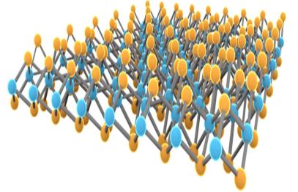

Figure : Two-dimensional structure of WTe2 [25] (Creative Commons License)

### 2.3.3 Xenes

Xenes are a group of 2D materials similar to graphenes, including silicenes, stanenes and germanenes. Here, the X in xenes stand for Si, Sn and Ge respectively. Xenes consist of group 13, 14 and 15 element atoms structured in a hexagonal lattice. [22] This lattice has variable amount of buckling throughout its structure, mainly due to presence of both sp2 as well as sp3 hybrid bonds. Xenes cannot be synthesized by top down approaches and have to be MLs grown on a substrate epitaxially. [1] A variety of xenes can be produced using Ag (111) as the substrate. The substrate chosen often controls the properties of the material, due to chemical reaction between the atoms and substrate. [26] Xenes have potential uses in FETs and topological insulators, however many of the xenes are unstable in ambient conditions. [1]

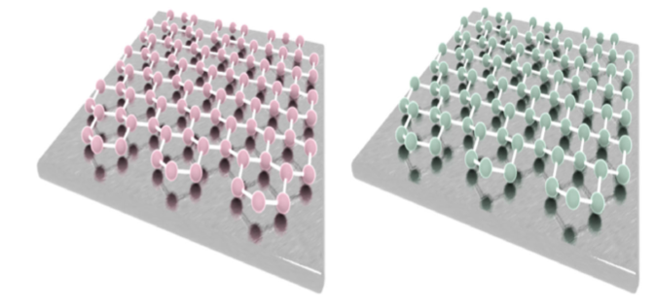

Figure : Buckled hexagonal structure of stanene and silicene, respectively [27] (Creative Commons License)

# 3. Molybdenum disulphide

## 3.1 Introduction

Molybdenum sulphide is a naturally occurring transition metal dichalcogenide, which has been present in nature for millenia. In the 1950s, early research was done on producing molybdenum disulphide by reducing MoS3, and high-temperature solution techniques. [28] Since graphene was isolated by Geim et al in 2004, research interest in two-dimensional materials was renewed. Recently, the focus has shifted to other two-dimensional materials similar to graphene, in order to handle the shortcomings of graphene and extend the potential of usage of 2D materials. Since then, MoS2 has become one of the most researched TMDC material.

## 3.2 Properties

In monolayer MoS2, Mo (+4) and S (2-) exist in a sandwich structure. They are held together by covalent bonding in a S-Mo-S order. [29] The sandwich layers interact with each other via weak vdW forces. The thickness of ML is roughly 6.5Å. 2D MoS2 is found to semi-conductive in nature in the trigonal prismatic molecular geometry (2H form). In the octahedral symmetry structure, 2D MoS2 is found to be metallic in nature and called the 1T form. [30]

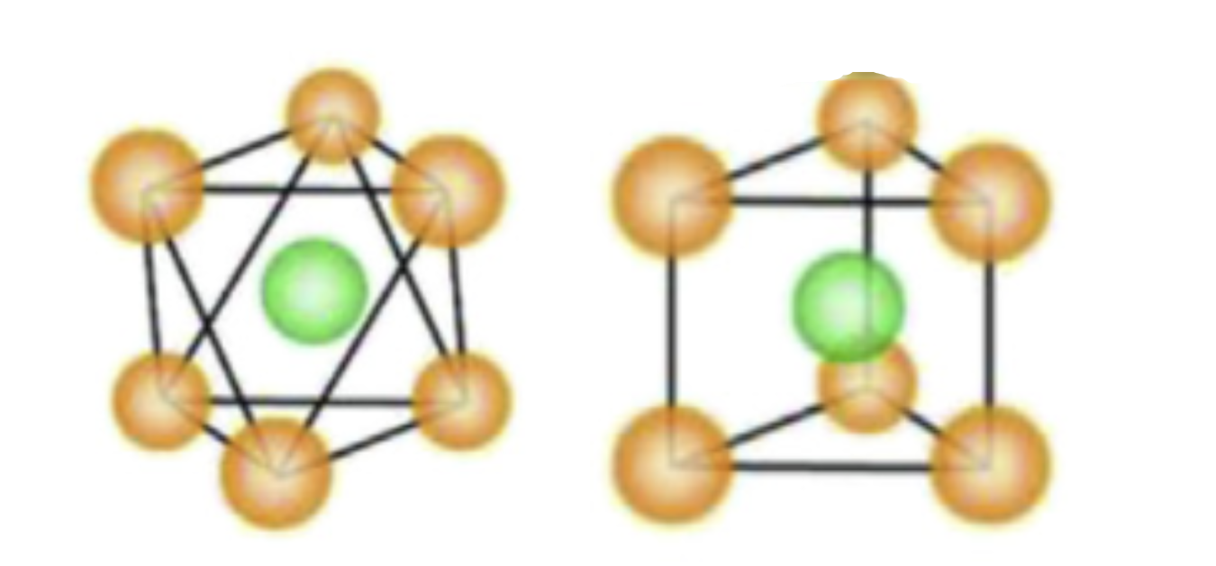

Figure : Types of monolayer MoS2: 1T (left), 2H (right) [31] (Creative Commons License)

The 2H structure, which contains 2 layers/unit cell is in hexagonal symmetry, is the most common stable phase seen in nature with ABA stacking. S atoms from distinct planes are perpendicular to one other and occupy the same locations. Mo-S bond is primarily covalent, whereas S layers are held together by vdW forces and glide easily over one another. The dislocation of one of the S layers produces 1T structure with an ABC layering sequence. [32] It features a trigonal symmetry and a symmetrical Mo-Mo bond. Since 1T phases contain more exposed active sites, they improve the electrical conductivity. The existence of filled dZ2 and empty dXY and dX2Y2 orbitals in 2H gives it semiconductor characteristics. The 4 d2 orbitals in 1T split into eg orbitals rather than t2g orbitals, resulting in metallic behaviour. The metallic nature of 1T is due to the two electrons occupied in t2g states. [32]

2D MoS2 is great elasticity and high strength with elastic modulus of roughly 0.33 TPa. [33] When MoS2 is exposed to strain, its elasticity prevents deformation and band gap alterations in its structure. Mechanical strain, on the other hand, is employed to change the electronic properties of MoS2 and convert it from a semiconductor to a metal. [32]

Several first principles based DFT studies have been undertaken to research the electrical properties of MoS2. The value of **κ** (high symmetry point in the first Brillouin zone) is determined by d-orbitals of Mo, and does not vary as size shrinks because it is unaffected by the number of layers. The valence band is made up of 2p orbitals of S. As a result, the bandgap between **κ** and **Γ** (another high symmetry point in the first Brillouin zone) varies, as the pz orbital of S and d orbital of Mo, determine the bandgap. The valence band maximum point decreases below zero as the number of layers decreases, forming a new point. This new VBM will have a new and increased bandgap of 1.9eV. [32]

When doped with Cr, Cu and Sc, ML MoS2 turns to n-type semiconductor. When doped with Ni or Zn, it turns into a p-type semiconductor. When doped with Ti, it changes its doped nature according to the concentration of Ti and point of doping. It acts like p-type conductor at low concentrations below 2.04%, and at 3.57% concentration with interstitial doping, it becomes an n-type semiconductor. This is because of the strong covalent linkage between MoS2 which causes dipole moment at the surface to rise. [34]

The charge mobility of MoS2 can go upto 0.2m2V-1S-1 at ambient temperature by using HfO2 for gate dielectric, according to Radisavljevic et al. [35] Conventionally, MoS2 FETs exhibit n-type behaviour. Monolayer MoS2 based phototransistors have great switching character, with the whole cycle of photocurrent induction and termination within 50 milliseconds, in a device developed by Yin et al. [36] The responsivity of this device can exceed that of graphene based devices, hence MoS2 can be used for devices like FETs, memory and photo-detectors.

Raman spectra is an approach to conveniently characterize for studying the evolution of structural characteristics in layered substances as they transition from 3D bulk blocks to 2D vdW bonded constructs, and they've been widely utilised to investigate graphene quality and layer number. MoS2 displays 4 active Raman modes under IR scattering. 2D monolayer MoS2 exhibits two peaks representing in-plane and out-of-plane vibrations of S atoms. If the number of layers rises, then the peaks are observed to have red shift and a blue shift respectively. [30]

Since bulk form needs more energy to transfer e- from valence band to conduction band, mobility of substance is greatly improved by decreasing its thickness and introduction of a direct bandgap. MoS2 can be utilized for diverse purposes via decreasing dimensions, intercalation or producing different heterostructures due to effect of the number of layers on optical characteristics.

Photoluminescence is inversely proportional to thickness of substance and can be utilised to calculate the number of layers in the material. Because of the direct bandgap at reduced thickness, the dominance of excitons reveals direct excitonic transition at point **κ**. In bulk, MoS2 has a low PL intensity due to weak phonon interaction and strong excitonic absorption that is larger than the indirect bandgap. The quantum confinement of electrons in d orbitals is responsible for this remarkable behaviour. When shifting from bulk to monolayer MoS2, photoluminescence and Raman showed similar behaviour tendencies. [30]

## 3.3 Applications of MoS2

### 3.3.1 Medical Applications

MoS2 has been extensively studied in the field of medicine particularly for cancer: cure as well as detection. According to Liu et al, MoS2/graphene oxide nanocomposites with doxorubicin were utilized to study and cure lung cancer in mice. [37]

By engineering defects in quantum dots of MoS2, Ding et al were able to kill cancer cells the sulfur defects caused a rise in oxidative stress, that is, disturbed the balance between formation of reactive oxygen free radicals and antioxidant defenses of the body. [38] This helped inhibit the growth of cancer cells.

In regards to cancer detection, Zheng et al were able to develop a MoS2 field effect transistor sensor to sense traces of H2O2 in cells. Photoluminescence were able to detect breast cancer by recording a red shift of 16 nanometers for the biomarker of breast cancer. [39]

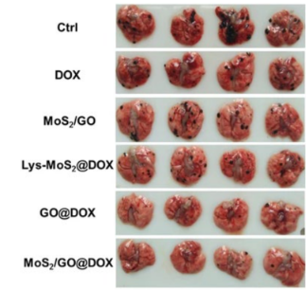

Figure : Effect of various agents on cancer cells in mice [37] (Creative Commons License)

### 3.3.2 Electronic Applications

Two dimensional MoS2 FETs can be utilized as operational amplifiers. Using amorphous Si and MoS2, Esmaeili-Rad and team were able to create a highly efficient and quick photodetector. Choi et al developed a MoS2-organic heterostructure image sensor with a simple architecture that is akin to a human vision system. This neuromorphic image sensor produces a cleaner output, with reduced noise and no redundant input information. [40]

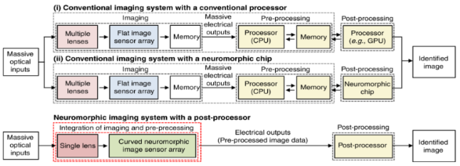

Figure : 1. Block diagram of conventional imaging system, 2. Neuromorphatic imaging device [40] (Creative Commons License)

The trapping effect in MoS2 stack causes delayed decay of the photocurrent and nearly linear generation of photocurrent, which depends on the time taken, which makes this image sensor possible. [40]

Sulphur treatment in alcohol improved back gate MoS2 transistors according to researched conducted by Sahoo and team, with gate lengths ranging from 5000 to 800 Å and contact resistances of 1.3K Ω.[41]

### 3.3.3 Energy Applications

MoS2 has been used in a variety of solar cells and Li-ion cells. By utilizing it as a buffer, Dey et al were able to develop a solar cell with improved stability and efficiency. [42] Another team was able to use the MoS2/silicon heterojunction to enhance conversion rate in solar cells by more than four times. [43] Huang et al used an anode made of MoS2 in Li-ion cells. After 50 cycles, this battery was able to maintain a reversible capacity of 786x10-3Ahg-1 at 10-1Ag-1 with a capacity of 1.103 AH. [44]

# 4. Point Defects

## 4.1 Introduction to defects in 2D materials

The structures of 2D materials, like other materials, invariably contain a variety of defects, such as vacancies, adatoms, grain boundaries, and substitutional impurities, all of which have a significant impact on their properties. Due to scattering from localised defects and GBs, the carrier mobility of graphene in electrics is greatly influenced by the amount of defects inside as well as its crystalline grain size. It has been shown that even a tiny quantity of imperfections in mechanically exfoliated graphene can significantly reduce carrier mobility. [45] Due to the development of a greater number of defects and grain boundaries, graphene produced by CVD often has poorer mobility than those that are mechanically exfoliated. Similarly, structural flaws hinder carrier mobility in TMDs devices, limiting their electrical and optoelectronic performance.

## 4.2 Types of defects in 2D materials

In two-dimensional materials, defects that occur can be intrinsic or extrinsic. The basis of classifying defects is mainly the dimensionality of defects. There are two types of defects:

1. Zero dimensional defects: Vacancy, Adatoms, SW defects, substitutional impurities
2. One dimensional defects: Line defects, edges, grain boundaries [45]

### 4.2.1 Zero Dimensional

#### 4.2.1.1 Vacancies

Vacancies along with the anti-sites that develop on them are the most basic and common flaws in 2D materials. Apart from the simple vacancy (where an atom is missing from the lattice structure), when more than two adjacent atoms are absent, bigger and more complicated defect structures occur. In graphene, double vacancies can be produced via coalescence of two single vacancies or by removing two adjacent atoms. TMDs can also have several types of vacancy flaws. MoS2 has various types of defects: S vacancy (one S atom missing referred to as VS), S2 vacancy (two S atoms missing, referred to as VS2), or Mo vacancy (one Mo atom missing referred to as VMo). [45]

Some vacancy flaws, on the other hand, are unstable, causing defect rebuilding. Single vacancy experiences jahn-teller effect in graphene, resulting in the creation of a 9-membered and 5-membered ring. [46]

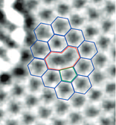

Figure : Reconstructed vacancy in graphene with atomic configuration - 9 and 5 membered ring [46] (Creative Commons License)

#### 4.2.1.2 Adatoms

Adatom are formed when foreign atoms are adsorbed onto 2D materials. Only physical adsorption happens when the contact between the foreign atom and 2D materials is weak. Covalent bonding between the foreign atom and the closest atom of 2D materials leads to chemical adsorption if the interaction force is greater. Chemisorption occurs primarily in three positions in graphene: in C-C bond, above C atoms, and entrapped by structural defects. [45]

#### 4.2.1.3 Stone Waller defect

Stone Waller defects are simple defects, which are created by reconstructing graphene lattice (switching between pentagons, hexagons, and septagons) with 90° rotations of carbon-carbon bonds in sp2-hybridized hexagonal C units. It can be created by cooling down quickly from a high temperature or by exposing it with electron beams. [45]

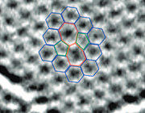

Figure : SW defect in graphene [46] (Creative Commons License)

#### 4.2.1.4 Substitutional defect

Substitutional impurities is the one of forms in which foreign atoms can be introduced into the crystal structure of two-dimensional materials. Because of their strong covalent bonding, substitutional dopants are predicted to be extremely stable. The Fermi level and the electrical structure of graphene can be changed by replacing C atoms with transition metal impurities, B or N atoms. [45]

### 4.2.2 One Dimensional

#### 4.2.2.1 Line Defects

Dislocations (or line defects) are caused by stresses experienced by the material during deformation. When material is deformed beyond the elastic limits, dislocation lines emerge, and extra-atom lines demarcate regions in the lattice where movement of one portion of crystal relative to another has occurred. The additional plane of atoms is the dislocation line, and the structure is deformed in its immediate vicinity. A pair of pentagon–septagons rings (5|7) is the most frequent dislocation in graphene. [22]

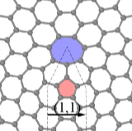

Figure : (1,1) Line defect in graphene [22] (Creative Commons License)

#### 4.2.2.2 Grain Boundary

Large-scale 2D material films produced via chemical vapour deposition are generally polycrystalline, and grain boundaries are a common form of defect that can have a significant impact on the characteristics of these materials. Grain boundary is a typical planar defect in 3D materials that separates two grains with different orientations. Misorientation is generally represented by an angle and is a key characteristic of grain boundary. The grain boundary is a line array of dislocation cores in the 2D lattice. [45]

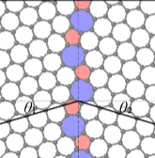

Figure : Grain boundary defect [22] (Creative Commons License)

**4.2.2.3 Edges**

Two dimensional materials have various types of edge terminations. These affect the structure as well as the characteristics of the materials. The manually exfoliated graphene sheets exhibit crystal cleavage characteristics since it is a perfect single crystalline structure. Most graphene angles are dispersed at roughly n x 30o, where n denotes a whole number in the range of 0 to 6, implying that graphene has zigzag or armchair edges, according to studies by You et al. [47]

## 4.3 Defects observed in MoS2

### 4.3.1 Point Defects

There are 4 different forms of vacancies and 2 different types of antisite faults commonly observed in the point defects of MoS2 structure. The mono vacancy of S (VS), divacancy of S pairs (VS2), and vacancy complex consisting of 1 molybdenum vacancy with three S vacancies (VMoS3) and molybdenum vacancy with three adjacent disulphur pairs (VMoS6) are among the vacancy defects. The antisite defects found are MoS2 (molybdenum atom replacing S2) and S2Mo (S2 column substituting

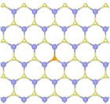

Figure : Sulphur monovacancy VS point defect [48] (Creative Commons License)

molybdenum atom). Vs, the defect with smallest enthalpy of formation (from DFT calculations), is

the most commonly observed defect and both the antisites, with higher enthalpy of formation than other defects, are rarely observed. [22]

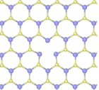

Figure : Vacancy complex VMoS3 [48]

According to atomistic imaging and spectroscopy studies conducted by Hus et al, substituting metal atom into sulphur vacancy creates non-volatile shift in resistance, which can be used in high-density information memory, computing and reconfigurable devices. [49]

### 4.3.1 Dislocations and GBs

MoS2 dislocation cores are usually shaped like a four-sided top and feature concave 3D polyhedra of consisting of multiple elements. A common dislocation structure in 2D materials comprised of hexagonal rings is the 5|7 dislocation core. These pairs have both Mo-rich and S-rich types with homoelemental links due to the presence of multiple elements. Burger vector of a 4|8 dislocation in MoS2 is greater in magnitude than that of a 5|7 dislocation, resulting in higher elastic deformation energy. The former is unstable and generally breaks down into 2 dislocations of the latter type, where there is a Mo-rich and S-rich core to maintain balance. [48]

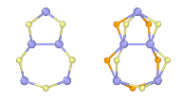

Figure : 5|7 dislocation in MoS2 [48] (Creative Commons License)

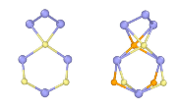

Figure : 4|6 dislocation in MoS2 [48] (Creative Commons License)

MoS2 has two different types of grain boundaries: asymmetric (asym-GB) and symmetric (sym-GB). Symmetric grain boundaries which are misoriented by 60o exhibit 4-fold rings which all share a point at a sulphur divacancy. This is called the 4|4P grain boundary. In 4|4E GB, the rings can share an edge. Symmetric grain boundaries are polar since there is a deficiency of one of the elements. Asymmetric grain boundaries are non-polar since both elements are equal in quantity. Energy of grain boundary over its length has a positive linear relationship with the tilt angle until a large value of tilt value is reached. [48]

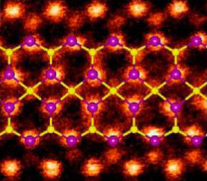

Figure : 4|4P 60o grain boundary structure [48] (Creative Commons License)

## 4.4 Why study point defects?

Modern microelectronics revolves around the field of band engineering. The path of customising and tweaking the lattice structure originates from doping, defects and heterostructuring to alter the atomic structure. A vast chunk of current electronics is built on Si FETs, optoelectronic devices made of Gallium arsenide, and LEDs of Gallium nitride and may be attributed to the remarkable triumph of modern band engineering. Although 2D material systems may hold the promise of future electronics, its band modulation/engineering techniques have not been investigated as comprehensively as the techniques responsible for mature silicon semiconductor systems. Despite the fact that 2D materials are shown to have unique and lucrative characteristics in transportation and solar applications, there is still a significant distance between laboratory research that is being performed and industrial use profiting off that research. Since structure disorder is a major aspect in most semiconductors, the same difficulty must be researched in the synthesis of 2D materials as well as scaling the same to industrial uses. [50]

# 5. Density Functional Theorem

## 5.1 Need for Computational Studies

Due to the fast advancement of contemporary computational chemistry, there is a rising need to comprehend the microscopic mechanisms that determine the characteristics of molecular and solid materials at the atomic level. The rules of quantum mechanics regulate interactions between atoms and electrons, necessitating the development of precise and efficient computer techniques to solve quantum-mechanical equations. [51]

Computational chemistry approaches have grown in significance in recent years, as established by their fast expanding applications in a wide range of fields, including molecular structure and property calculations, pharmaceutical drug design, and invention of new materials, among others. The size of the systems that one is able to analyse computationally has risen because of this. Hence, this has created even more need for large-scale applications. This is occurring because bigger molecular systems exhibit fascinating phenomena and have significant consequences in current biochemistry, biotechnology, and nanotechnology. [51]

## 5.2 Origin of Computational Studies

The density functional theory (DFT) proposed by Kohn and Sham in 1965 was a game-changer in these endeavours, and it has had an incomparable influence on a wide range of intriguing and difficult issues in computational chemistry during the last couple of decades. When benchmarked against other wave-function-based techniques like CC theory or MP perturbation theory, DFT's true strength is its favourable price/performance ratio. As a result, DFT can be utilized to study large-scale molecular and solid systems with adequate precision, extending the predictive potential of electronic structure theory. As a result, DFT is currently by far the most commonly utilised approach for determining electrical structure. [51]

Recent advances in ML techniques have allowed for molecular dynamics simulations at a large scale with ab initio precision, and this technology has been used to a wide range of applications. The considerable parallelism afforded by powerful computer networks and scalable programming approaches on high performance computing have spurred enormous advancements in the capabilities of computational chemistry simulations over the last few decades. The diversity of relevant data structures and methods, as well as the often occurring intrinsic sequential control, make optimal utilisation of a large number of processors challenging. Hence, designing parallel architecture with good efficiency is a demanding task.

By using the monoparticle Green's function, the Green's function technique gives information similar from that obtained by solving the Kohn-Sham equation. Lowered scaling in the computations of metallic systems is a significant benefit of the MST technique. The multiple scattering theory technique demonstrates the capability of massively parallel supercomputers to model increasingly complex materials and provides a dependable and accessible method for large-scale ab initio simulations of metals and alloys. [52]

The ab initio molecular dynamics method has been widely used to investigate the real-time information of electronic systems. Due to the presence of static correlation, it is still exceedingly difficult to forecast the electrical characteristics of radical systems using ab initio DFT calculations. DFT framework has undergone another wave of rapid evolution in combination with HPC and ML approaches. DFT methods with more efficient algorithms and greater accuracy are likely to be released in the near future. [51]

# 6. Results

## 6.1 Background

We study the effects of inducing point defects in the structure of 2D materials using Quantum Espresso. In the PWscf package of Quantum Espresso, we utilize a plane-wave basis set along with pseudopotentials to perform self-consistent calculations of electron structure characteristics within density functional theory. Using bands package, we plot the band structure of the material sample.

## 6.2 Computation Process

We use norm-conserving pseudopotentials, developed by researchers at Fritz Haber Institute of the Max Planck Society, for performing first principles based DFT calculations. We have picked MoS2 as the material of choice to study point defects as it is one of the most representative of materials among several TMDCs. At first, we simulate a unit cell of MoS2 and perform self-consistent calculations in order to optimize the structure of the unit cell.

The flowchart of optimization process of the unit cell is given below.

Figure : Flowchart of unit cell optimization

The self-consistent field method is an iterative technique of obtaining the electronic characteristics of material. SCF calculates the difference in total energy while altering electron density differentially to estimate ground-state electron density. The computation is complete when the energy hits the global minimum and achieves convergence in its value.

The value of convergence threshold on total energy is by default 10-4 Ry and is lowered to 10-6 Ry for our purposes. When the difference between two consecutive values of final energy is below this convergence threshold, then the calculation is stopped.

After selecting the FHI norm conserving pseudo potential files for molybdenum and sulphur, we perform kinetic energy cutoff optimization. The greater the value of kinetic energy cutoff, the greater is the definition of the wave function. Assuming 10 k-points for the first round of self-consistent calculations, we calculate energy for different values of kinetic energy cutoff from 10 to 150 Ry at intervals of 10 by performing self-consistent field calculations.

Figure : Optimization of Kinetic Energy Cutoff

Here, we can see that the graph converges to a value at kinetic energy cutoff value of 60 Ry. Hence, we use this value in the next iteration of self-consistent field calculations.

Next, we optimize the value of k-points. Bloch's theorem states that integrals in real space over the system spread infinitely over space are substituted by integrals in reciprocal space over the finite first Brillouin zone. Further, such integrals are computed by adding values of the integrand at a limited no. of points in the first Brillouin zone. These points are together called the k point mesh and a sufficient density of this mesh is required to ensure that the calculation converges. We try to optimize k point by sampling different values of Monkhorst-Pack grid, which defines k-points as distributed evenly in the first BZ, parallel to the reciprocal lattice vectors. Since we are performing calculations for a 2D material, the number of k points in Z direction is kept as 1. The Monkhorst-Pack grid of NxNx1 is iterated to calculate values of total energy at different values of N from 2 to 20.

Figure : Optimization of Monkhorst-Pack Grid

Here, we can see that the graph converges to a value of N at 10. Hence, the Monkhorst Pack grid we’ll use is a 10x10x1 pack. Now that we’ve optimized k points and kinetic energy cutoff, we’ll proceed to relax the unit cell.

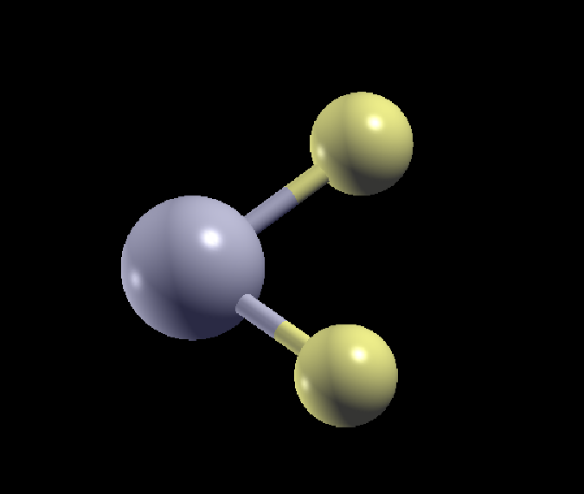

Figure : 1x1x1 MoS2 unit cell, visualized in Xcrysden

We use the vcrelax package of PWscf, which relaxes the unit cell and allows changing of the cell parameters to ensure that unit cell is under near zero stress. To relax all the parameters of the unit cell, the Broyden-Fletcher-Goldfarb-Shanno quasi-Newton algorithm was applied to the cell dynamics of the unit cell. We also restrict the relaxation of cell parameters to the X and Y plane. After performing the cell relaxation, we obtain the final cell parameters and atomic positions of the 3 atoms. In the final iteration, pressure becomes zero. We obtain value of highest occupied energy level as   
-1.1973eV and value of lowest unoccupied level as 0.7318eV. Since bandgap is the difference between these two values, we obtain a bandgap of 1.9291eV, which is close to the theoretical value of 1.8eV for 2D MoS2 from literature. [53]

Next, we proceed to calculate the band structure of the unit cell. Before that, we proceed to perform non-self consistent field calculations. Then we use the bands calculation feature of PWscf package which computes the Kohn-Sham states for the a given set of k-points. The k-points given here are the high symmetry path, Γ-K-M-Γ, with k-points obtained from the ‘K-Path selection’ feature in Xcrysden.

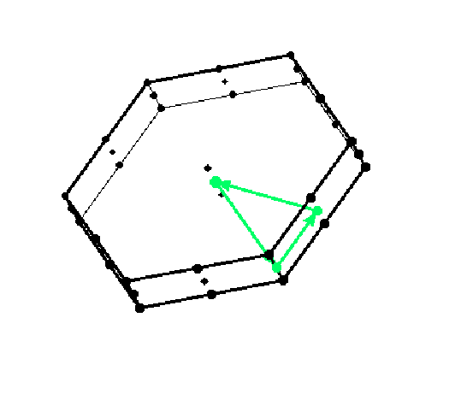

Figure : K-Path Selection

We also use the bands.x package to carry out band-related calculations and finally obtain the points for the band structure, which we plot in Excel.

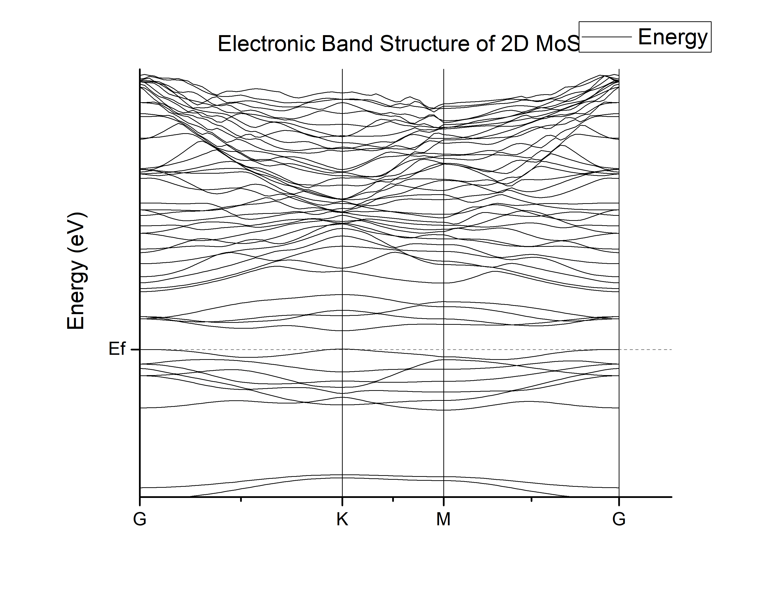

Figure : Band structure of pristine monolayer MoS2

We also proceed to perform calculate density of states at different energy levels using dos.x package of Quantum Espresso.

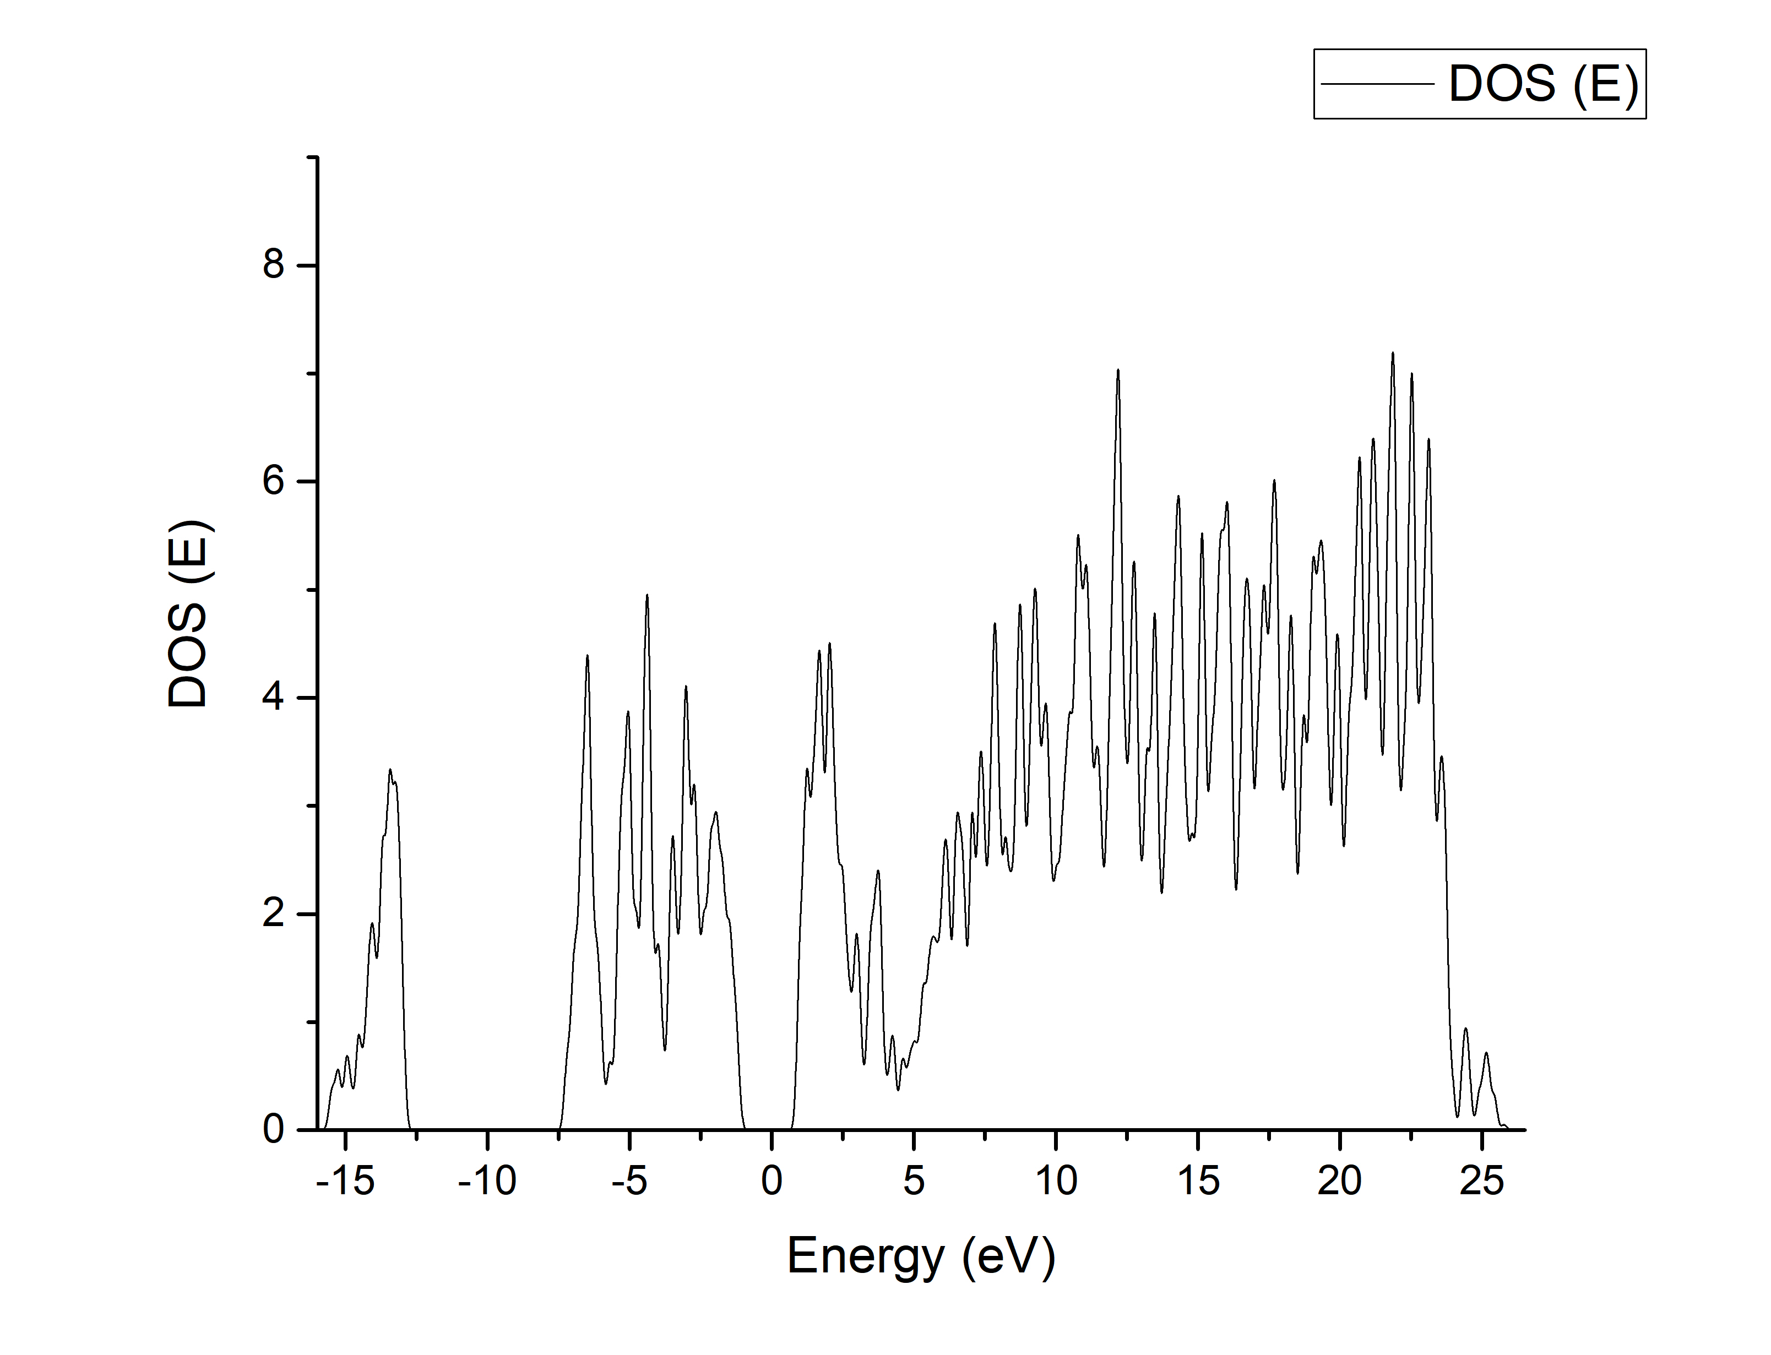

Figure : Density of states for pristine monolayer MoS2

Next, we repeat the above process for a 3x3 super-cell. We take an optimal Monkhorst Pack Grid of

9x9x1 and optimal kinetic energy cutoff of 60 Ry. But before we perform variable cell relaxation, we must induce a defect.

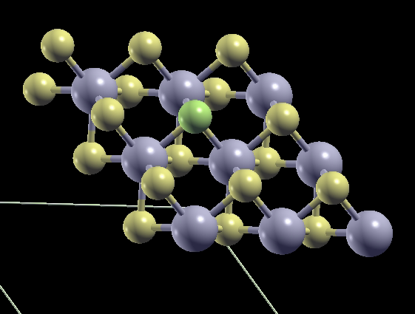

Figure : 3x3x1 MoS2 supercell, visualized in Xcrysden, with S atom to be removed marked in green

First, we induce the VS defect by removing an S atom from the atomic position configuration in the input file. We also enable Grimme’s dispersion correction to take into account the presence of long-range van der Waals effect in the system.

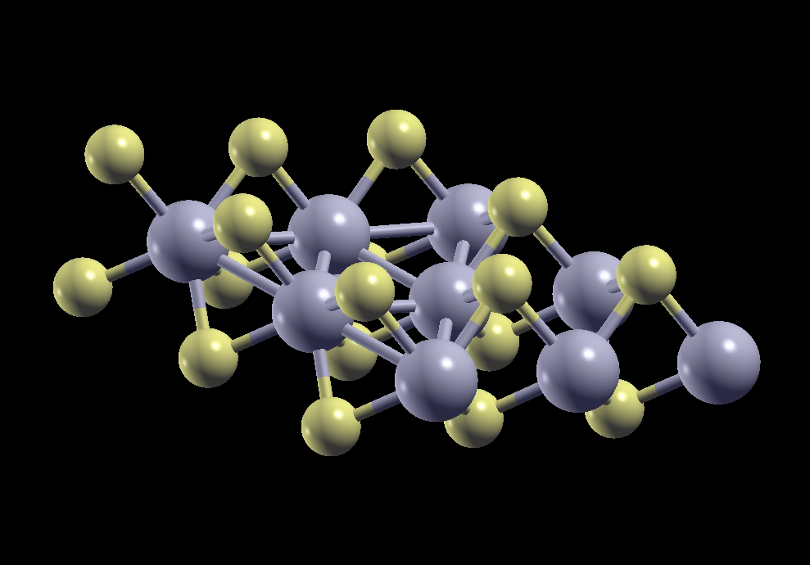

Figure : 3x3x1 MoS2 supercell, visualized in Xcrysden, with S atom removed

Then, we implement the variable cell relaxation and obtain the final cell parameters and atomic positions of the 26 atoms present in the 3x3 super cell. After performing self-consistent field calculations, we obtain a band gap of 1.2548 eV, comparable to 1.12 eV value in theory. [53]

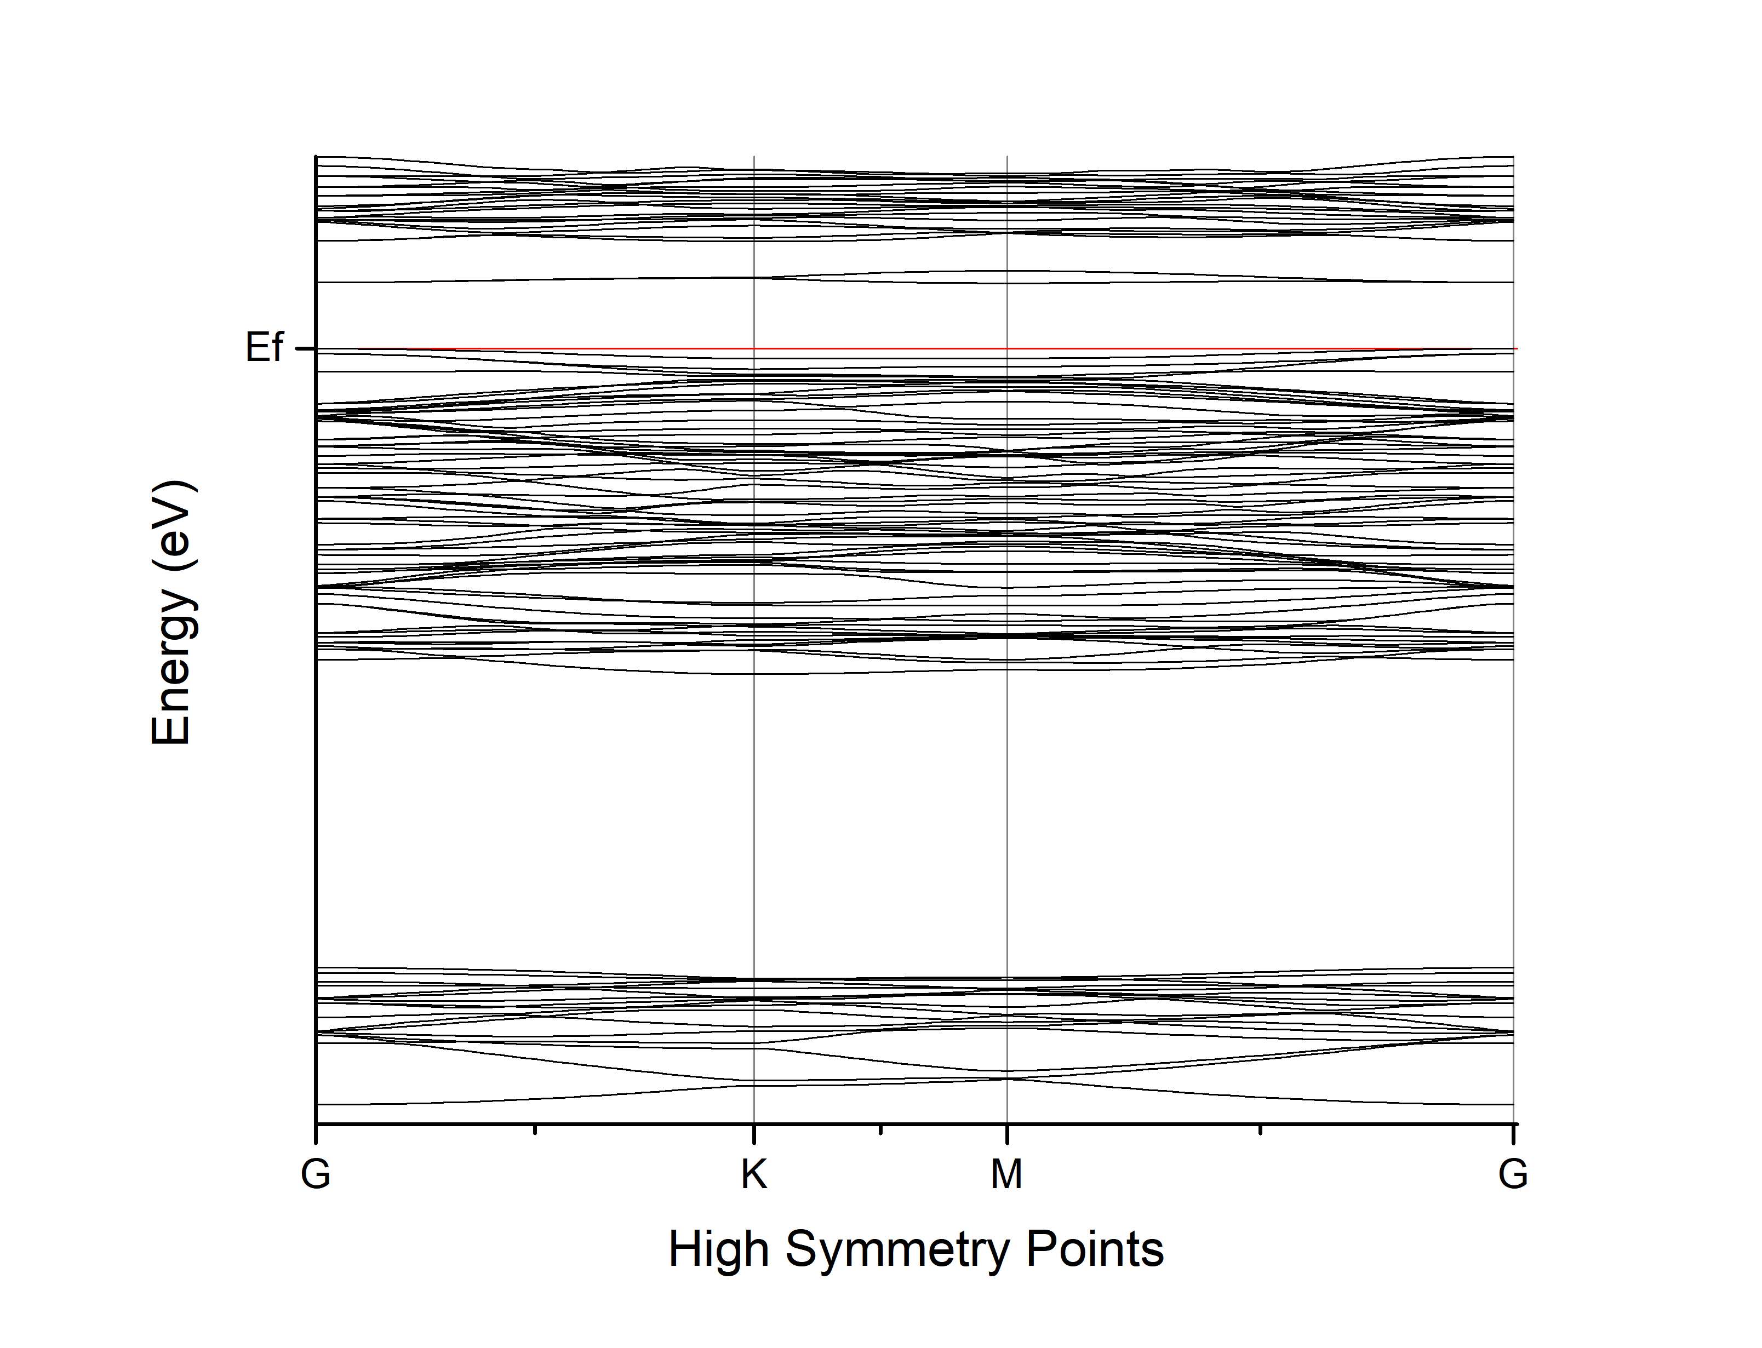

Figure : Band structure of MoS2 with Vs defect

The increase in number of bands is due to increasing the nbnd value which specifies the number of electronic states to be calculated.

We can also observe that introducing a sulphur defect resulted in a significant reduction in bandgap, a phenomenon which is corroborated by literature. [53]

Next, we perform non self-consistent field calculations. Then, we proceeded to calculate band structure as stated before. We also plot density of states with respect to different energy levels, given in the figure on the next page.

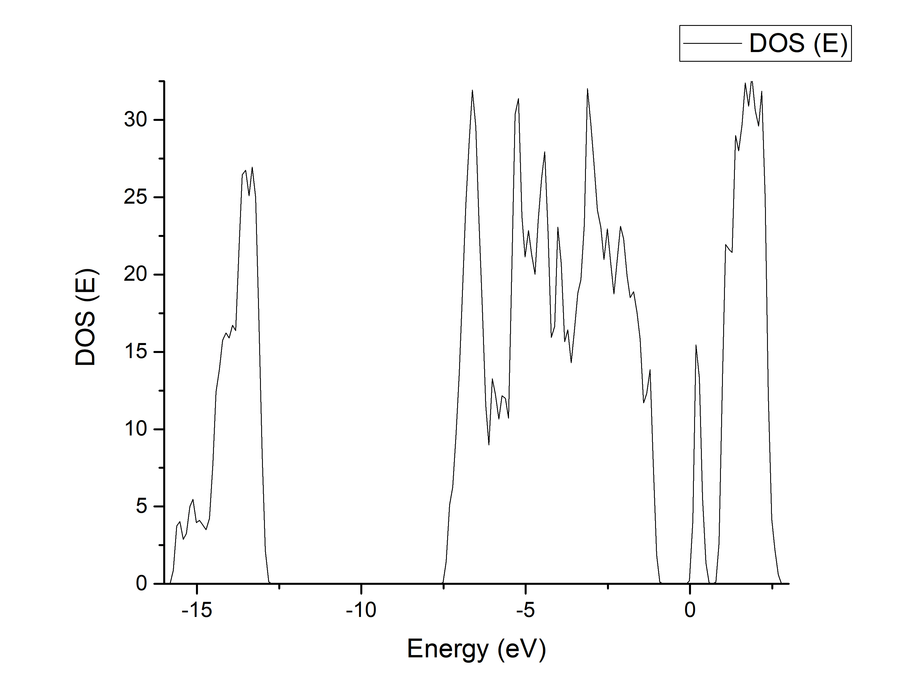

Figure : Density of states plot of MoS2 with Vs defect

As we can see in the above, density of states of defect states increases with introduction of sulphur vacancy.

# 7. Summary & Future work

## 7.1 Summary

Starting off with an introduction to classification of materials based on dimensionality, we delved further into the world of two-dimensional materials. After studying the properties of 2D materials with respect to where electrical mechanical and optical characteristics, we examined the two types of synthesis techniques of 2D materials. Then we examine some important 2D material types such as graphene, TMDCs and xenes. In the next chapter, we delved deeper into molybdenum sulphide, a representative material for TMDCs and studied its various properties and electronic applications.

We examine the different types of defects present in 2D materials based on the dimensionality and further, examine the type of defects in MoS2 in detail. Further, we justify why studying point defects is necessary. The next chapter elucidates a brief history of computational studies and why we utilize computational methods in our report. The following chapter contains the results from the simulations run by us in Quantum Espresso.

## 7.2 Future Work

We can examine the effect of introducing multiple sulphur and molybdenum vacancies on the band structure and density of states. Further, we can extend self-consistent field calculations to other types of defects such as substitutional defects. Replacing Mo or S atom with atoms of other elements will yield different and interesting results, that can be extended for various applications, as in the paper by Hus et al. [49]

# 8. References

|  |  |
| --- | --- |
| [1] | M. Tahir and U. Fatima, “Recent trends and emerging challenges in two-dimensional materials for energy harvesting and storage applications,” *Energy Storage,* 2021. |
| [2] | V. V. Skorokhod and V. V. Pokropivny, “Classification of nanostructures by dimensionality and concept of surface forms engineering in nanomaterial science,” *Materials Science and Engineering,* vol. 27, no. 5-8, pp. 990-993, 2007. |
| [3] | R. N. T. K. S. K. Jitendra N. Tiwari, “Zero-dimensional, one-dimensional, two-dimensional and three-dimensional nanostructured materials for advanced electrochemical energy devices,” *Progress in Materials Science,* vol. 57, no. 4, pp. 724-803, 2012. |
| [4] | G. A. M. S. J. D. Z. Y. D. S. G. I. F. A. Novoselov KS, “Electric field effect in atomically thin carbon films,” *Science,* vol. 306, no. 5696, pp. 666-669, 2004. |
| [5] | M. J. D. &. Z. H. Chhowalla, “Two-dimensional semiconductors for transistors,” *Nature Reviews Materials,* vol. 1, no. 16052, 2016. |
| [6] | N. G. M. S. P. e. a. Mounet, “Two-dimensional materials from high-throughput computational exfoliation of experimentally known compounds,” *Nature Nanotech,* vol. 13, p. 246–252, 2018. |
| [7] | S. Lim, S. Kang, T. Yoo, S. Lee and H. Hwang, “Operation Mechanism of a MoS2/BP Heterojunction FET,” *Nanomaterials,* vol. 8, no. 797, 2018. |
| [8] | W. Park, Y. Pak, H. Jang, J. Nam, T. Kim, S. Oh, S. Choi, Y. Kim and Cho, “Improvement of the Bias Stress Stability in 2D MoS2 and WS2 Transistors with a TiO2 Interfacial Layer,” *Nanomaterials,* vol. 9, no. 1155, 2019. |
| [9] | B. Cho and Y. Kim, “Preparation and Properties of 2D Materials,” *Nanomaterials,* vol. 10, no. 764, 2020. |
| [10] | J. Lee, C. Park, T. Kim, Y. Kim and E. Kim, “K. Characteristics of P-type Conduction in P-doped MoS2 by Phosphorous Pentoxide during Chemical Vapor Deposition,” *Nanomaterials,* vol. 9, no. 1278, 2019. |
| [11] | W. Park, H. Jang, J. Nam, J. Kwon, B. Cho and Y. Kim, “Artificial 2D van der Waals Synapse Devices via Interfacial Engineering for Neuromorphic Systems,” *Nanomaterials,* vol. 10, no. 88, 2020. |
| [12] | C. Ko, “Reconfigurable Local Photoluminescence of Atomically-thin Semiconductors Via Ferroelectric-assisted Effects,” *Nanomaterials,* vol. 9, no. 1620, 2019. |
| [13] | S. Liang, M. Hasan and J. Seo, “Direct Observation of Raman Spectra in Black Phosphorus under Uniaxial Strain Conditions,” *Nanomaterials,* vol. 9, no. 566, 2019. |
| [14] | R. Zhang and R. Cheung, “Mechanical Properties and Applications of Two-Dimensional Materials,” in *Two-dimensional Materials - Synthesis, Characterization and Potential Applications*, InTech, 2016. |
| [15] | S. Z. Yi M, “A review on mechanical exfoliation for the scalable production of graphene,” *J Mater Chem,* vol. 3, no. 22, pp. 11700-11715, 2015. |
| [16] | Y. H-D, “Chemical routes to top-down nanofabrication,” *Chem Soc Rev,* vol. 42, no. 14, pp. 6006-6018, 2013. |
| [17] | H. J-K, “Large-area synthesis of highly crystalline WSe2 monolayers and device applications,” *ACS Nano,* vol. 8, no. 1, pp. 923-930, 2014. |
| [18] | G. A. M. S. Novoselov KS, “Two-dimensional gas of massless Dirac fermions in graphene,” *Nature,* vol. 438, pp. 197-200, 2005. |
| [19] | D. W. a. K. M. I. a. L. A. I. Boukhvalov, “Hydrogen on graphene: Electronic structure, total energy, structural distortions and magnetism from first-principles calculations,” *Phys. Rev. B,* vol. 77, no. 3, 2008. |
| [20] | W. Bao, X. Cai, D. Kim, K. Sridhara and M. Fuhrer, “High Mobility Ambipolar MoS2 Field-Effect Transistors: Substrate and Dielectric Effects,” *Appl. Phys. Lett,* vol. 102, no. 042104, 2013. |
| [21] | L. C, “Measurement of the elastic properties and intrinsic strength of monolayer graphene,” *Science,* vol. 321, no. 5887, pp. 385-388, 2008. |
| [22] | L. Z. H. W. a. X. L. Zixin Xiong, “Structural Defects, Mechanical Behaviors, and Properties of Two-Dimensional Materials,” *Materials (Basel),* vol. 14, no. 5, 2021. |
| [23] | D. J. F. S. T. J. B. V. V. K. S. V. M. A. K. G. K. S. Novoselov, “Two-dimensional atomic crystals,” in *Proceedings of the National Academy of Sciences*, 2005. |
| [24] | J. A. R. Eric M. Vogel, “Two-dimensional layered transition-metal dichalcogenides for versatile properties and applications,” *MRS Bulletin,* vol. 40, no. 7, pp. 558-563, 2015. |
| [25] | C. W, “Recent development of two-dimensional transition metal dichalcogenides and their applications,” *Mater Today,* vol. 20, no. 3, pp. 116-130, 2017. |
| [26] | B. Feng, Z. Ding, S. Meng, Y. Yao, X. He, P. Cheng, L. Chen and K. Wu, “ K. Evidence of silicene in honeycomb structures of silicon on Ag(111),” *Nano Lett. ,* vol. 12, p. 3507–3511, 2012. |
| [27] | E. M, “Fundamentals and functionalities of silicene, germanene, and stanene,” *Riv Nuovo Cimento,* vol. 41, pp. 175-224, 2018. |
| [28] | F. T. E. a. R. M. Roberts, “Molybdenum disulfide of high surface area,” *J. Phys. Chem.,* vol. 63, 1959. |
| [29] | S. V. L. L. M. T. H. M. Jariwala D, “Emerging Device Applications for Semiconducting Two-Dimensional Transition Metal Dichalcogenides,” *ACS Nano,* vol. 8, no. 2, p. 1102–1120, 2014. |
| [30] | H. Z. Xiao Li, “Two-dimensional MoS2: Properties, preparation, and applications,” *Journal of Materiomics,* vol. 1, no. 1, pp. 33-44, 2015. |
| [31] | Y. H. V. D. F. T. C. M. C. M. Eda G, “Photoluminescence from chemically exfoliated MoS2,” *Nano Lett,* vol. 11, pp. 5111-5116, 2011. |
| [32] | S. M. K. N. K. O. P. F. A. G. G. M. S. P. N. Thomas, “2D MoS2: structure, mechanisms, and photocatalytic applications,” *Materials Today Sustainability,* vol. 13, 2021. |
| [33] | P. N. H. J. Akinwande D, “Two-dimensional flexible nanoelectronics,” *Nat Commun.,* vol. 5, no. 5678, 2014. |
| [34] | S. Z. M. D. B. A. E. M. Omnia Samy, “A Review on MoS2 Properties, Synthesis, Sensing Applications,” *Crystals,* vol. 11, no. 4, p. 355, 2021. |
| [35] | R. A. B. J. G. V. K. A. Radisavljevic B, “Single-layer MoS2 transistors,” *Nat Nanotechnol ,* vol. 6, no. 147, p. e50., 2011. |
| [36] | L. H. L. H. J. L. S. Y. S. Y. Yin Z, “Single-layer MoS2 phototransistors,” *ACS Nano,* vol. 6, pp. 74-80, 2012. |
| [37] | Y. Liu, J. Peng, S. Wang, M. Xu, M. Gao, T. Xia, J. Weng, A. Xu and S. Liu, “Molybdenum Disulfide/Graphene Oxide Nanocomposites Show Favorable Lung Targeting and Enhanced Drug Loading/Tumor-Killing Efficacy with Improved Biocompatibility,” *NPG Asia Mater,* vol. 10, 2018. |
| [38] | X. Ding, F. Peng, J. Zhou, W. Gong, G. Slaven, K. Loh, C. Lim and D. Leong, “Defect Engineered Bioactive Transition Metals Dichalcogenides Quantum Dots,” *Nat. Commun.,* vol. 10, no. 41, 2019. |
| [39] | S. Catalán-Gómez, M. Briones, S. Cortijo-Campos, T. García-Mendiola, A. de Andrés, S. Garg, P. Kung, E. Lorenzo and J. Pau, “Breast Cancer Biomarker Detection through the Photoluminescence of Epitaxial Monolayer MoS2 Flakes,” *Scientific Reports,* vol. 10, no. 16039, 2020. |
| [40] | C. Choi, J. Leem, M. Kim, A. Taqieddin, C. Cho, K. Cho, G. Lee, H. Seung, H. Bae and Y. Song, “Curved Neuromorphic Image Sensor Array Using a MoS2-Organic Heterostructure Inspired by the Human Visual Recognition System,” *Nat. Commun. ,* vol. 11, no. 5934, 2020. |
| [41] | S. Sanjay, K. Sahoo and N. Bhat, “Alcohol-Based Sulfur Treatment for Improved Performance and Yield in Local Back-Gated and Channel-Length-Scaled MoS2 FETs,” *IEEE Trans. Electron Devices,* vol. 67, p. 3711–3715, 2020. |
| [42] | M. Dey, M. Dey, S. Alam, N. Das, M. Matin and N. Amin, “Study of Molybdenum Sulphide as a Novel Buffer Layer for CZTS Solar Cells,” in *3rd International Conference on Electrical Engineering and Information Communication Technology*, Dhaka, 2016. |
| [43] | H. Xu, L. Xin, L. Liu, D. Pang, Y. Jiao, R. Cong and W. Yu, “W. Large Area MoS2/Si Heterojunction-Based Solar Cell through Sol-Gel Method,” *Mater. Lett. ,* vol. 238, p. 13–16, 2019. |
| [44] | Y. Huang, Y. Wang, X. Zhang, F. Lai, Y. Sun, Q. Li and H. Wang, “N-Doped Carbon@nanoplate-Assembled MoS2 Hierarchical Microspheres as Anode Material for Lithium-Ion Batteries,” *Mater. Lett. ,* vol. 243, p. 84–87, 2019. |
| [45] | Z. a. N. Z. Wu, “Spectroscopic investigation of defects in two-dimensional materials,” *Nanophotonics,* vol. 7, no. 7, 2016. |
| [46] | C. K. R. E. M. D. R. M. F. C. A. Z. Jannik C. Meyer, “Direct Imaging of Lattice Atoms and Topological Defects in Graphene Membranes,” *Nano Letters,* vol. 8, no. 11, pp. 3582-3586, 2008. |
| [47] | N. Z. Y. T. S. Z. You YM, “Edge chirality determination of graphene by Raman spectroscopy,” *Appl Phys Lett ,* vol. 93, no. 3112, 2008. |
| [48] | X. Z. S. N. Z. L. Y. S. J. K. J. L. P. M. A. B. I. Y. a. J.-C. I. Wu Zhou, “Intrinsic Structural Defects in Monolayer Molybdenum Disulfide,” *Nano Lett. ,* vol. 13, no. 6, p. 2615–2622, 2013. |
| [49] | S. G. R. C. P. e. a. Hus, “Observation of single-defect memristor in an MoS2 atomic sheet,” *Nat. Nanotechnol. ,* vol. 16, pp. 58-62, 2021. |
| [50] | C. J. J. Y. Z. Z. Jinhua Hong, “Atomic Defects in Two-Dimensional Materials: From Single-Atom Spectroscopy to Functionalities in Opto-/Electronics, Nanomagnetism, and Catalysis,” *Advanced Materials,* vol. 29, no. 14, 2017. |
| [51] | M. C. Wei Hu, “Advances in Density Functional Theory and Beyond for Computational Chemistry,” *Front Chem,* vol. 9, 2021. |
| [52] | P. a. S. P. V. Lloyd, “Multiple Scattering Theory in Condensed Materials,” *Adv. Phys. ,* vol. 21, p. 69–142, 1972. |
| [53] | L. T. Z. X.-D. Yang Ke, “Bandgap Engineering and Near-Infrared-II Optical Properties of Monolayer MoS2: A First-Principle Study,” *Frontiers in Chemistry,* vol. 9, p. 433, 2021. |
| [54] | Z. W. a. Z. Ni, “Spectroscopic investigation of defects in two dimensional materials,” *Nanophotonics,* vol. 151, 2016. |